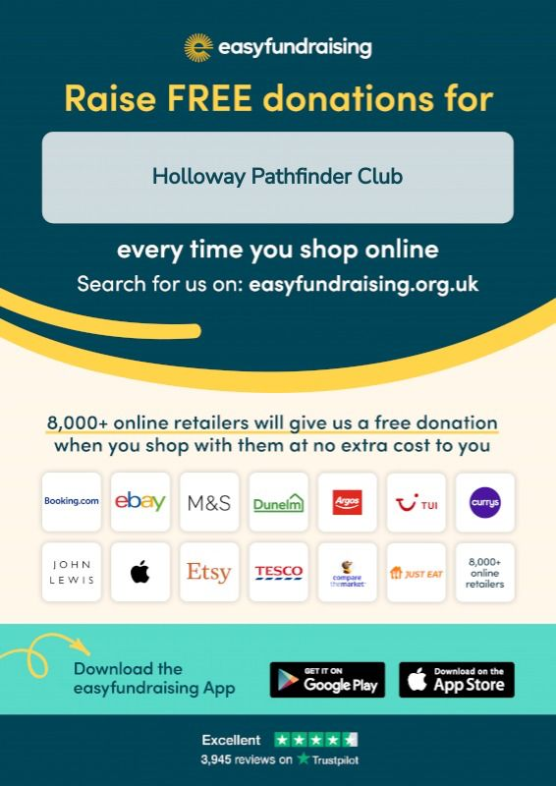

Support Pathfinder Club through easyfundraising, your everyday online shopping can help us provide equipment, uniforms, and experiences for young people at no extra cost to you.

How it works:

Shop online with over 7,000 brands like John Lewis, Argos, Amazon, and eBay.

Brands donate a percentage to our cause.

Download the free easyfundraising app to start raising donations automatically.
PLEASE REMEMBER TO SELECT HOLLOWAY PATHFINDER CLUB AS YOUR CAUSE, IN ORDER FOR OUR PATHFINDER CLUB TO RECEIVE THE MONIES.
Make an impact: www.easyfundraising.org.uk

Shop. Give. Change lives. We thank you in advance for supporting Holloways Pathfinder Club.

